Case Study 4: Accident Case – Fall from Pallet Raised by Forklift (Forklift Misused to Lift Persons)
Accident Case (Forklift Operations) | Duration: 60 minutes
1) Instructor Instructions (Facilitation Guide)
- Clarify: forklifts are designed for goods handling; lifting persons requires purpose-built equipment and controls.
- Encourage groups to propose elimination/substitution before administrative controls.
- Link discussion to key control/unauthorised use prevention and supervision.
2) Learning Outcomes
- Recognise hazards and consequences of using forklifts to lift/transport people.
- Identify control measures: correct equipment selection, SWP/RA, key control and supervision.
- Develop prevention plan aligned to safe work-at-height principles and forklift intended use.
3) Session Plan (60 minutes)
Time | Activity
0–10 min | Briefing: objectives, ground rules, roles (operator/spotter/pedestrian), overview of scenario.
10–25 min | Group reading of scenario + clarify terminology and site layout.
25–45 min | Group work: complete Hazard/Risk tables + propose controls + reporting actions.
45–55 min | Plenary: groups present; facilitator challenges assumptions; consolidate best controls.
55–60 min | Quick knowledge check + key takeaways + sign-off/attendance.

4) Case Study Scenario
To reach equipment at height in a warehouse, a worker steps onto a pallet placed on forklift forks. A co-worker operates the forklift to raise the pallet so the worker can access the elevated task. The forklift key is left in the ignition, enabling easy access. While working at height on the pallet, the worker loses balance and falls to the ground, resulting in fatal/serious injury.
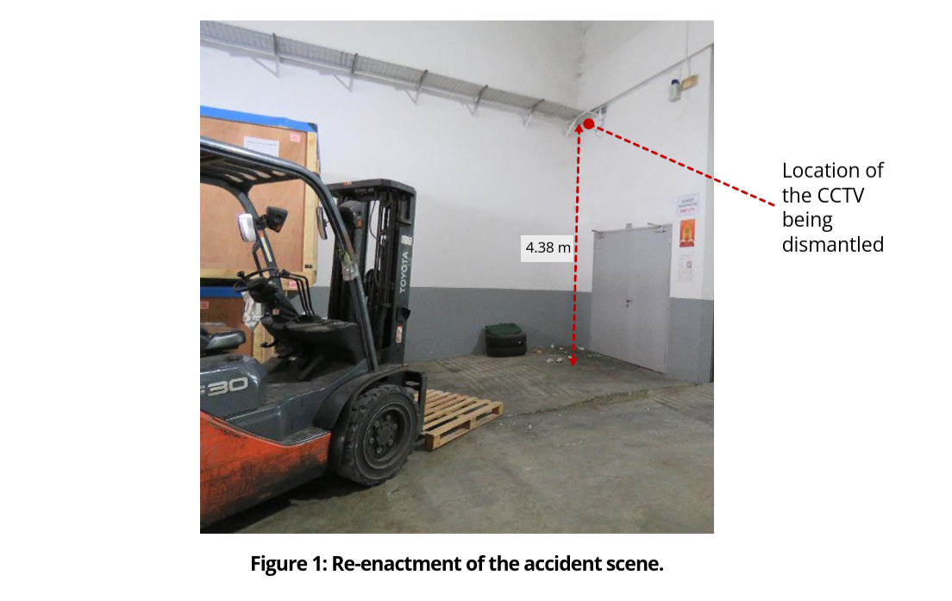
5) Learner Tasks / Instructions
- Identify the hazards associated with lifting persons on pallets/forks (at least 8 hazards).
- Propose safer alternatives (equipment and method) to complete the work at height.
- Draft a SWP outline for work-at-height tasks near forklifts (max 10 bullets).
- Complete the Hazard/Risk worksheet and corrective action plan.
- Create a “Do/Don’t” poster message (one paragraph) for notice boards.
6) Hazard Identification & Risk Assessment Worksheet (Template)
Step/Area | Hazard | Who may be harmed | Possible consequence | Existing controls | Risk (L/M/H/E) | Additional controls (Elim/Subst/Eng/Admin/PPE) | Person in charge | Target date

Risk Rating Matrix (Sample)
Severity \ Likelihood | 1 Rare | 2 Unlikely | 3 Possible | 4 Likely | 5 Almost Certain
1 Minor | L | L | L | M | M
2 Moderate | L | L | M | M | H
3 Major | L | M | M | H | H
4 Serious | M | M | H | H | E
5 Fatal | M | H | H | E | E

Legend: L=Low, M=Medium, H=High, E=Extreme

7) Corrective Action & Follow-up (Template)
Action item | Owner | Due date | Resources needed | Verification method | Status

8) Discussion Questions (Template)
No. | Question | Group notes (blank)
Q1 | Why is lifting a person on forks/pallet inherently high-risk? Identify the failure points.
Q2 | What are the most effective controls (elimination/substitution/engineering) for this task?
Q3 | What key-control and authorisation measures prevent unauthorised forklift use?
Q4 | How should supervision and permit-to-work (if used) be applied to non-routine tasks?
Q5 | What training/refresher measures help prevent recurrence of unsafe shortcuts?

9) Sample Answers (Facilitator Copy)
Question | Sample answer (key points)
Q1 | Failure points: no secured work platform, no fall protection/guardrails, instability/sway, sudden movement, operator error, poor communication, uneven floor, distraction; consequences include fatal falls and crush injuries.
Q2 | Controls: use MEWP/scaffold/approved man-basket designed for lifting persons; engineer guardrails; prohibit forklift use for lifting persons; enforce exclusion zones.
Q3 | Implement controlled key access (keys held by authorised operators only), sign-in/out logs, and disciplinary controls for misuse; never leave key in ignition.
Q4 | Non-routine tasks require planning, RA, clear SWP, competent supervision, and (where applicable) permit-to-work with pre-task briefing and checks.
Q5 | Ensure operators complete required training and periodic refresher training; reinforce lessons from past incidents and common safety lapses; conduct toolbox talks and competency checks.

10) Observation Checklist (Facilitator)
Competency element | Observed? (Y/N) | Comments
Identifies key hazards (people, load, environment, equipment)
Assesses risk realistically (severity/likelihood)
Selects effective controls (hierarchy applied)
Communicates and reports hazards/unsafe acts promptly
Demonstrates understanding of authorised operator / key control
Applies safe operating principles (speed, blind spots, load low)

11) Knowledge Check (5 quick questions)
No. | Question | Answer (blank)
Q1 | List two reasons why forklifts should be operated only by authorised/trained operators.
Q2 | State two controls that reduce forklift–pedestrian collision risks.
Q3 | What should you do if your forward view is obstructed by the load?
Q4 | Give two examples of conditions that increase tip-over risk.
Q5 | What is the correct action if a forklift defect is discovered during checks?

12) References (WSHC / MOM)
- WSH Council (WSHC), “Forklift-related Workplace Fatal Injuries in 2H2023” (WSH Advisory): https://www.tal.sg/wshc/-/media/tal/wshc/resources/newsletters/wsh-bulletins/files/forklift-related-workplace-fatal-injuries-in-2h2023.ashx
- Workplace Safety and Health Council, “WSH Guidelines: Safe Operation of Forklift Trucks” (2012).

