Case Study 3: Accident Case – Worker Struck by Forklift Forks During Bulk Bag Handling
Accident Case (Forklift Operations) | Duration: 60 minutes
1) Instructor Instructions (Facilitation Guide)
- Emphasise “learning review” approach: focus on system gaps (training, supervision, controls).
- Prompt groups to separate: immediate causes vs contributing factors vs root/system causes.
- Ensure learners propose controls that are practical at the workplace level.
2) Learning Outcomes
- Analyse immediate and underlying causes of a forklift strike incident.
- Identify safety precautions to prevent recurrence (authorisation, safe positioning, equipment use).
- Apply reporting, preservation of evidence, and corrective action planning.
3) Session Plan (60 minutes)
Time | Activity
0–10 min | Briefing: objectives, ground rules, roles (operator/spotter/pedestrian), overview of scenario.
10–25 min | Group reading of scenario + clarify terminology and site layout.
25–45 min | Group work: complete Hazard/Risk tables + propose controls + reporting actions.
45–55 min | Plenary: groups present; facilitator challenges assumptions; consolidate best controls.
55–60 min | Quick knowledge check + key takeaways + sign-off/attendance.

4) Case Study Scenario
During a task to position forklift forks through the lifting handles of a bulk bag, a worker stands in front of the forklift to guide positioning. The forklift is operated by a supervisor who is not trained/authorised to operate the forklift. As the forklift moves forward, the forks strike the worker, resulting in severe injury (fatal outcome in the real-world reference case).
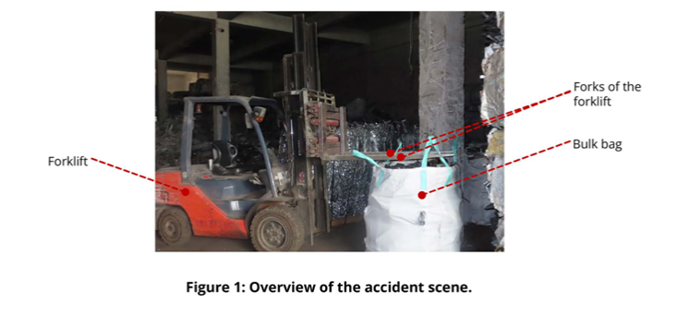
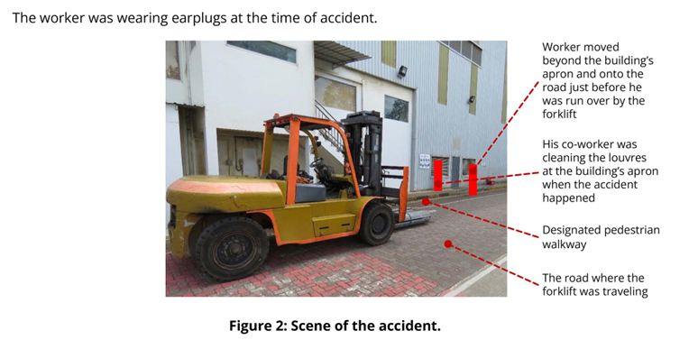
5) Learner Tasks / Instructions
- Map the sequence of events (timeline) leading to the incident.
- Identify at least 5 immediate causes and 5 underlying/system causes.
- Recommend safety precautions: work positioning/exclusion zones, authorised operator controls, load handling method, supervision.
- Complete the Corrective Action Plan (Section 7) and assign owners/dates.
- Draft a toolbox briefing message (max 6 bullets) for workers next shift.
6) Hazard Identification & Risk Assessment Worksheet (Template)
Step/Area | Hazard | Who may be harmed | Possible consequence | Existing controls | Risk (L/M/H/E) | Additional controls (Elim/Subst/Eng/Admin/PPE) | Person in charge | Target date

Risk Rating Matrix (Sample)
Severity \ Likelihood | 1 Rare | 2 Unlikely | 3 Possible | 4 Likely | 5 Almost Certain
1 Minor | L | L | L | M | M
2 Moderate | L | L | M | M | H
3 Major | L | M | M | H | H
4 Serious | M | M | H | H | E
5 Fatal | M | H | H | E | E

Legend: L=Low, M=Medium, H=High, E=Extreme

7) Corrective Action & Follow-up (Template)
Action item | Owner | Due date | Resources needed | Verification method | Status

8) Discussion Questions (Template)
No. | Question | Group notes (blank)
Q1 | What were the immediate unsafe acts/conditions that led to the injury?
Q2 | What system failures allowed an untrained person to operate the forklift?
Q3 | How should ground guiding be conducted safely (positioning, communication)?
Q4 | What alternative methods/equipment could reduce the need for a person to be in front of forks?
Q5 | What reporting and follow-up steps should happen within 24 hours of the incident?

9) Sample Answers (Facilitator Copy)
Question | Sample answer (key points)
Q1 | Immediate issues: worker standing in line of travel/forks, forklift moving while person in danger zone, inadequate communication/exclusion zone.
Q2 | System failures: weak authorisation control, poor key control, lack of supervision/verification, inadequate competency management/training records.
Q3 | Ground guide should never stand in front of moving forklift/forks; use agreed hand signals/radios; maintain safe distance at side with clear escape route; stop forklift before fine positioning.
Q4 | Use appropriate attachments/handling method, pre-position bag/handles, use tag lines, or mechanical aids so no one is in front of forks; redesign workflow to eliminate line-of-fire exposure.
Q5 | Report to supervisor/safety immediately, secure scene if required, collect witness statements/CCTV timings, isolate equipment, conduct investigation, implement interim controls and communicate lessons learned.

10) Observation Checklist (Facilitator)
Competency element | Observed? (Y/N) | Comments
Identifies key hazards (people, load, environment, equipment)
Assesses risk realistically (severity/likelihood)
Selects effective controls (hierarchy applied)
Communicates and reports hazards/unsafe acts promptly
Demonstrates understanding of authorised operator / key control
Applies safe operating principles (speed, blind spots, load low)

11) Knowledge Check (5 quick questions)
No. | Question | Answer (blank)
Q1 | List two reasons why forklifts should be operated only by authorised/trained operators.
Q2 | State two controls that reduce forklift–pedestrian collision risks.
Q3 | What should you do if your forward view is obstructed by the load?
Q4 | Give two examples of conditions that increase tip-over risk.
Q5 | What is the correct action if a forklift defect is discovered during checks?

12) References (WSHC / MOM)
- WSH Council (WSHC), “Forklift-related Workplace Fatal Injuries in 1H2024” (WSH Advisory), 9 Oct 2024: https://www.tal.sg/wshc/-/media/tal/wshc/resources/newsletters/wsh-bulletins/files/forklift-related-workplace-fatal-injuries-in-1h2024.ashx
- Workplace Safety and Health Council, “WSH Guidelines: Safe Operation of Forklift Trucks” (2012).

