Case Study 2: Hazard Identification – Loading Dock/Ramp & Confined Container Loading
Hazard Identification Case (Forklift Operations) | Duration: 60 minutes
1) Instructor Instructions (Facilitation Guide)
- Prepare a sketch of a dock: dock leveler, trailer, chocks, pedestrian route, lighting points.
- Provide teams a copy of the risk matrix and worksheet templates (Sections 6–7).
- Prompt learners to consider both routine and non-routine tasks (e.g., urgent loading, damaged pallets).
2) Learning Outcomes
- Identify hazards associated with ramps, docks, slopes, and confined loading spaces.
- Explain how ground conditions, trailer movement, and visibility contribute to incidents.
- Select controls for safe loading/unloading (immobilisation, spotting, signage, housekeeping).
- Apply stop-work and reporting actions when unsafe conditions are found.
3) Session Plan (60 minutes)
Time | Activity
0–10 min | Briefing: objectives, ground rules, roles (operator/spotter/pedestrian), overview of scenario.
10–25 min | Group reading of scenario + clarify terminology and site layout.
25–45 min | Group work: complete Hazard/Risk tables + propose controls + reporting actions.
45–55 min | Plenary: groups present; facilitator challenges assumptions; consolidate best controls.
55–60 min | Quick knowledge check + key takeaways + sign-off/attendance.

4) Case Study Scenario
At a loading bay, forklifts enter a container/trailer to load pallets. The approach includes a short ramp with a slight slope. During rainy days, water is tracked onto the ramp and dock plate. The loading area is partially enclosed, making it dim in the container. A spotter is not always assigned. On some occasions, the vehicle driver remains in the cab and the trailer may move slightly. Workers stack pallets near the dock edge, narrowing the turning space.
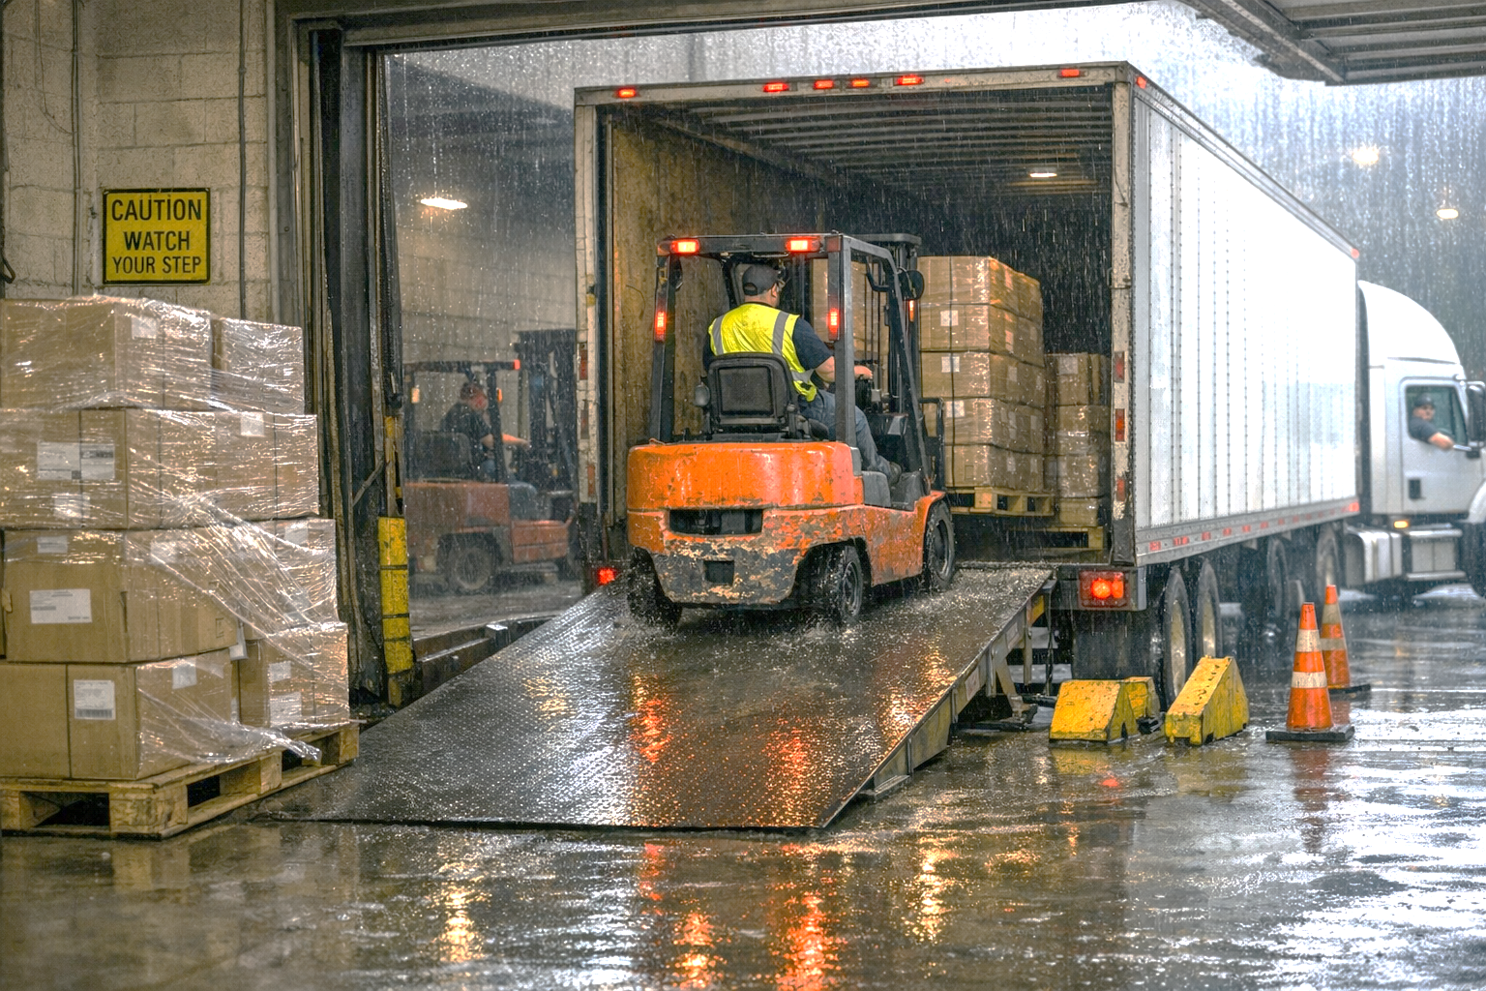

5) Learner Tasks / Instructions
- List hazards specific to ramps/docks and confined container loading.
- Complete the Hazard Identification & Risk Assessment Worksheet (Section 6) for at least 8 hazards.
- Propose controls: vehicle immobilisation, pedestrian control, lighting/visibility, floor conditions, and safe approach speed.
- Define criteria for “stop work” and how to escalate the issue.
- Draft a short Safe Work Procedure (SWP) summary (max 8 bullet points) for dock loading.
6) Hazard Identification & Risk Assessment Worksheet (Template)
Step/Area | Hazard | Who may be harmed | Possible consequence | Existing controls | Risk (L/M/H/E) | Additional controls (Elim/Subst/Eng/Admin/PPE) | Person in charge | Target date

Risk Rating Matrix (Sample)
Severity \ Likelihood | 1 Rare | 2 Unlikely | 3 Possible | 4 Likely | 5 Almost Certain
1 Minor | L | L | L | M | M
2 Moderate | L | L | M | M | H
3 Major | L | M | M | H | H
4 Serious | M | M | H | H | E
5 Fatal | M | H | H | E | E

Legend: L=Low, M=Medium, H=High, E=Extreme

7) Corrective Action & Follow-up (Template)
Action item | Owner | Due date | Resources needed | Verification method | Status

8) Discussion Questions (Template)
No. | Question | Group notes (blank)
Q1 | What can go wrong when a forklift enters/exits a trailer or container? List at least five failure modes.
Q2 | How do wet/slippery surfaces and slopes affect braking distance and stability?
Q3 | What measures ensure the vehicle/trailer is immobilised before loading/unloading?
Q4 | What visibility controls are needed inside a container/trailer?
Q5 | What should workers do if the turning space is restricted by stored pallets near the dock edge?

9) Sample Answers (Facilitator Copy)
Question | Sample answer (key points)
Q1 | Failure modes: trailer creep/pull-away, forklift slipping on dock plate, edge drop-off, low clearance strike, poor visibility leading to collision, unstable pallets shifting.
Q2 | Wet surfaces reduce tyre grip and increase stopping distance; slopes shift centre of gravity; sudden steering/braking increases tip-over risk.
Q3 | Use wheel chocks/dock locks, apply parking brakes, communication with vehicle driver, “keys with driver/permit” controls, and clear sign-off before forklift entry.
Q4 | Provide adequate lighting, ensure clear line of sight, use spotter/ground guide when view is impeded, slow approach and horn at entry.
Q5 | Stop and re-housekeep: remove obstructions, re-establish safe turning radius, set exclusion zones; do not proceed in cramped conditions without controls.

10) Observation Checklist (Facilitator)
Competency element | Observed? (Y/N) | Comments
Identifies key hazards (people, load, environment, equipment)
Assesses risk realistically (severity/likelihood)
Selects effective controls (hierarchy applied)
Communicates and reports hazards/unsafe acts promptly
Demonstrates understanding of authorised operator / key control
Applies safe operating principles (speed, blind spots, load low)

11) Reporting Form (Unsafe / Unauthorised Forklift Practice) – Template
Field | Entry
Date & time observed
Location
Forklift ID / type
Description of unsafe/unauthorised act
Immediate action taken (stop work / isolate / key control)
Persons involved / witnesses (if known)
Photos/CCTV reference (if any)
Reported to (name/role) and time
Corrective action required
Follow-up owner & close-out date

12) Knowledge Check (5 quick questions)
No. | Question | Answer (blank)
Q1 | List two reasons why forklifts should be operated only by authorised/trained operators.
Q2 | State two controls that reduce forklift–pedestrian collision risks.
Q3 | What should you do if your forward view is obstructed by the load?
Q4 | Give two examples of conditions that increase tip-over risk.
Q5 | What is the correct action if a forklift defect is discovered during checks?

13) References (WSHC / MOM)
- WSH Council (WSHC), “Operating Forklifts Safely” topic page: https://www.tal.sg/wshc/topics/forklift/operating-forklifts-safely
- Workplace Safety and Health Council, “WSH Guidelines: Safe Operation of Forklift Trucks” (2012).
- Ministry of Manpower (MOM) Circular MOM/OSHD/2025-01 (3 Jan 2025) on mandating forklift refresher training: https://www.mom.gov.sg/-/media/mom/documents/safety-health/circulars/2025/circular-20250103-mandating-forklift-operator-refresher-training-course.pdf

