Case Study 1: Hazard Identification – Mixed Traffic, Blind Spots & Pedestrian Interface
Hazard Identification Case (Forklift Operations) | Duration: 60 minutes
1) Instructor Instructions (Facilitation Guide)
- Print or display the scenario. Prepare flip charts/markers for group work.
- Brief learners that the goal is hazard spotting + risk reduction, not blame.
- Assign groups of 3–5: facilitator, scribe, presenter.
- Remind learners to consider: people, equipment, load, environment, and procedures.
- If available, show a simple site map with pedestrian walkway crossing a forklift route.
2) Learning Outcomes
- Identify common hazards when forklifts operate near pedestrians and at blind corners.
- Describe likely consequences (collision, crush injury, property damage) and assign risk levels.
- Propose practical controls using the hierarchy of control and a Traffic Management Plan approach.
- Apply clear reporting and escalation actions for unsafe/unauthorised practices.
3) Session Plan (60 minutes)
Time | Activity
0–10 min | Briefing: objectives, ground rules, roles (operator/spotter/pedestrian), overview of scenario.
10–25 min | Group reading of scenario + clarify terminology and site layout.
25–45 min | Group work: complete Hazard/Risk tables + propose controls + reporting actions.
45–55 min | Plenary: groups present; facilitator challenges assumptions; consolidate best controls.
55–60 min | Quick knowledge check + key takeaways + sign-off/attendance.

4) Case Study Scenario
A warehouse uses counterbalance forklifts to move palletised goods between receiving, storage aisles, and the staging area. The area is busy: pedestrians cut across forklift routes to reach printers and packing tables. Two blind corners exist where racks block line of sight. The floor has occasional wet patches near the shrink-wrap station. Operators report being pressured to “move faster” during peak hours. One forklift is observed reversing out of an aisle with the load raised higher than necessary.
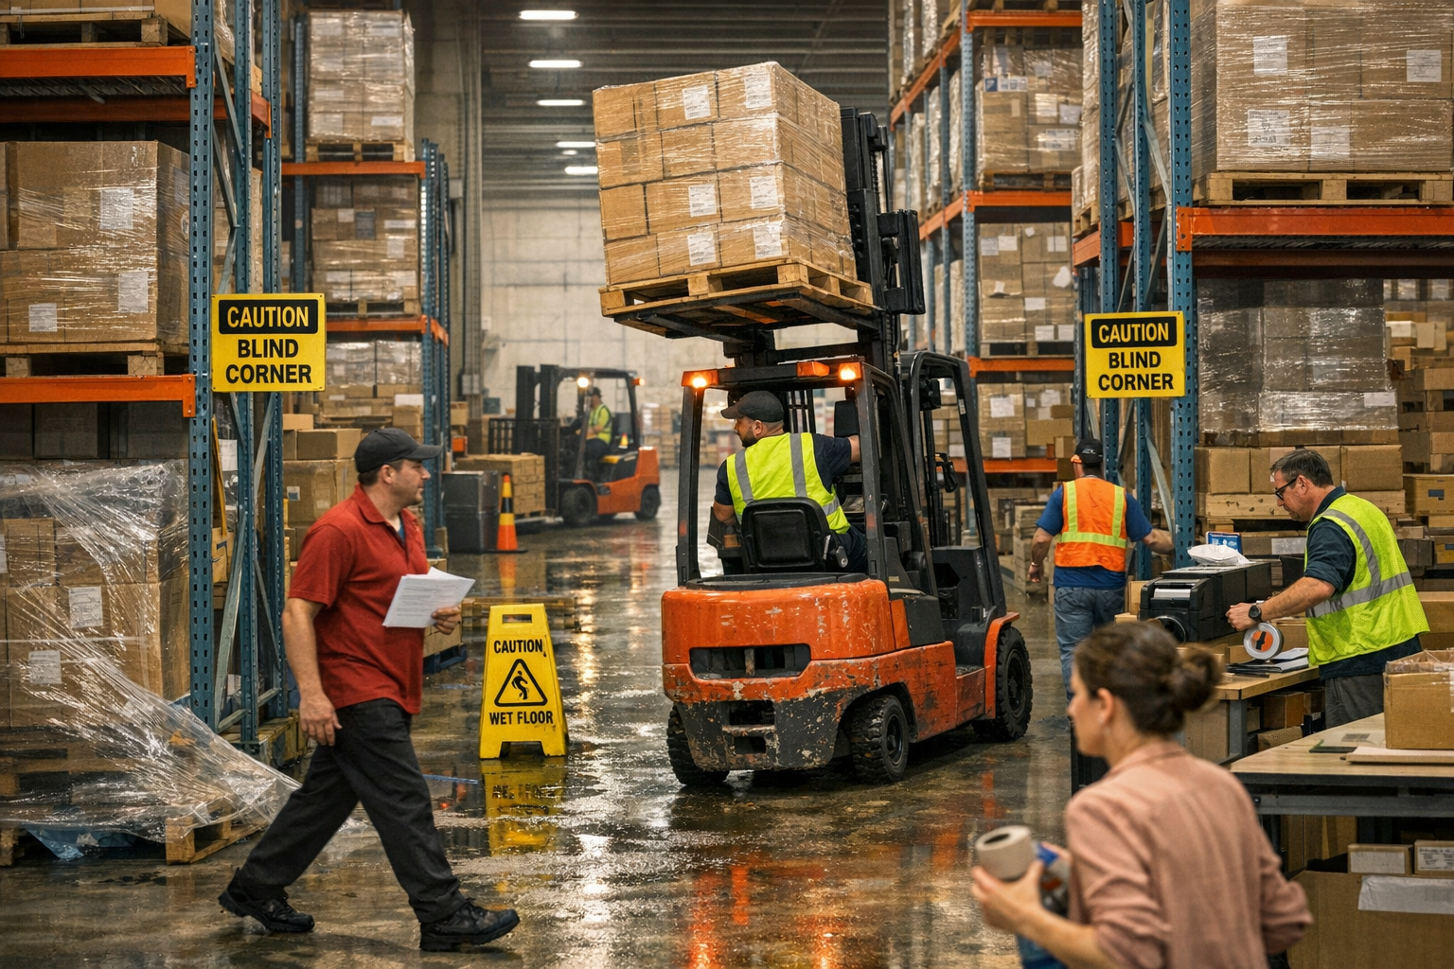
5) Learner Tasks / Instructions
- Identify at least 10 hazards in the scenario (people, environment, equipment, behaviour).
- Complete the Hazard Identification & Risk Assessment Worksheet (Section 6).
- Recommend controls to reduce collision and tip-over risks (engineering + administrative + PPE).
- Define a reporting pathway when an unsafe or unauthorised act is observed.
- Prepare a 2–3 minute presentation of the top 3 risks and top 3 controls.
6) Hazard Identification & Risk Assessment Worksheet (Template)
Step/Area | Hazard | Who may be harmed | Possible consequence | Existing controls | Risk (L/M/H/E) | Additional controls (Elim/Subst/Eng/Admin/PPE) | Person in charge | Target date

Risk Rating Matrix (Sample)
Severity \ Likelihood | 1 Rare | 2 Unlikely | 3 Possible | 4 Likely | 5 Almost Certain
1 Minor | L | L | L | M | M
2 Moderate | L | L | M | M | H
3 Major | L | M | M | H | H
4 Serious | M | M | H | H | E
5 Fatal | M | H | H | E | E

Legend: L=Low, M=Medium, H=High, E=Extreme

7) Corrective Action & Follow-up (Template)
Action item | Owner | Due date | Resources needed | Verification method | Status

8) Discussion Questions (Template)
No. | Question | Group notes (blank)
Q1 | What are the highest-risk pedestrian–forklift interaction points in this scenario and why?
Q2 | Which unsafe behaviours are present, and what might be driving them?
Q3 | What Traffic Management Plan measures would you implement immediately vs longer-term?
Q4 | How would you control risk when visibility is obstructed (blind corners, load blocking view)?
Q5 | What should be reported, to whom, and what immediate actions should be taken?

9) Sample Answers (Facilitator Copy)
Question | Sample answer (key points)
Q1 | Crossings and blind corners are highest risk due to poor visibility and mixed traffic; consequences include crush injuries/fatalities.
Q2 | Unsafe behaviours include speeding/pressure to rush, reversing without full checks, carrying load too high; drivers include production pressure and weak supervision.
Q3 | Immediate: segregate routes with cones/barriers, enforce speed limit, horn at corners, high-visibility vest, spotters at peak. Longer-term: physical barriers/guard rails, one-way systems, convex mirrors, dedicated pedestrian walkways and gates.
Q4 | Lower loads to improve visibility; reverse only when safe; use a ground guide/spotter; install mirrors/lighting; stop if unsure.
Q5 | Report unsafe acts/defects immediately to supervisor/safety; stop work if imminent danger; isolate forklift if defective; record details (time, location, forklift ID, description) and corrective actions.

10) Observation Checklist (Facilitator)
Competency element | Observed? (Y/N) | Comments
Identifies key hazards (people, load, environment, equipment)
Assesses risk realistically (severity/likelihood)
Selects effective controls (hierarchy applied)
Communicates and reports hazards/unsafe acts promptly
Demonstrates understanding of authorised operator / key control
Applies safe operating principles (speed, blind spots, load low)

11) Reporting Form (Unsafe / Unauthorised Forklift Practice) – Template
Field | Entry
Date & time observed
Location
Forklift ID / type
Description of unsafe/unauthorised act
Immediate action taken (stop work / isolate / key control)
Persons involved / witnesses (if known)
Photos/CCTV reference (if any)
Reported to (name/role) and time
Corrective action required
Follow-up owner & close-out date

12) Knowledge Check (5 quick questions)
No. | Question | Answer (blank)
Q1 | List two reasons why forklifts should be operated only by authorised/trained operators.
Q2 | State two controls that reduce forklift–pedestrian collision risks.
Q3 | What should you do if your forward view is obstructed by the load?
Q4 | Give two examples of conditions that increase tip-over risk.
Q5 | What is the correct action if a forklift defect is discovered during checks?

13) References (WSHC / MOM)
- WSH Council (WSHC), “Forklift-related Workplace Fatal Injuries in 1H2024” (WSH Advisory), 9 Oct 2024: https://www.tal.sg/wshc/-/media/tal/wshc/resources/newsletters/wsh-bulletins/files/forklift-related-workplace-fatal-injuries-in-1h2024.ashx
- WSH Council (WSHC), “Operating Forklifts Safely” topic page: https://www.tal.sg/wshc/topics/forklift/operating-forklifts-safely

